

ARISTOLOCHIA BRACTEOLATA

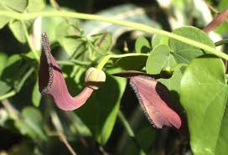**BOTANICAL NAME: *Aristolochia bracteolata***

**FAMILY:** Aristolochiaceae

**SYNONYMS:**

**ENGLISH:** 'worm killer'

**HINDI:** Kirmar

**TAMIL:** Adutinnapaalai

**TELUGU:** Gadatigadaparaku.

**CHEMICAL CONSTITUENTS:**

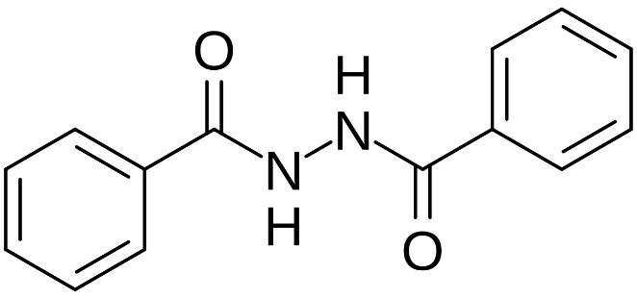phenanthrene-1-carboxylic acid that is substituted by a methylenedioxy group at the 3,4 positions, by a methoxy group at position 8, and by a nitro group at position 10.

**USES:**

* In some traditional medicine systems, bracteated birthwort has been used for its potential therapeutic effects. It's been employed in treating various ailments, though specific uses can vary by region and tradition.
* Some research suggests that plants in the Aristolochia genus, including *A. bracteolata*, may possess anti-inflammatory properties. This can be useful for managing conditions associated with inflammation.
* Preliminary studies have indicated that bracteated birthwort may have antioxidant properties, which can help combat oxidative stress in the body.
* Traditionally, certain Aristolochia species have been used to support digestive health. However, it's crucial to approach this with caution, as some members of the Aristolochia genus are known for their potential toxicity and adverse effects.